IPD System Update Change Logs Document

1. Database

* Create New Tables, Procedure and Function
* Create New Database Views

1. Application

* Add New Menu Group

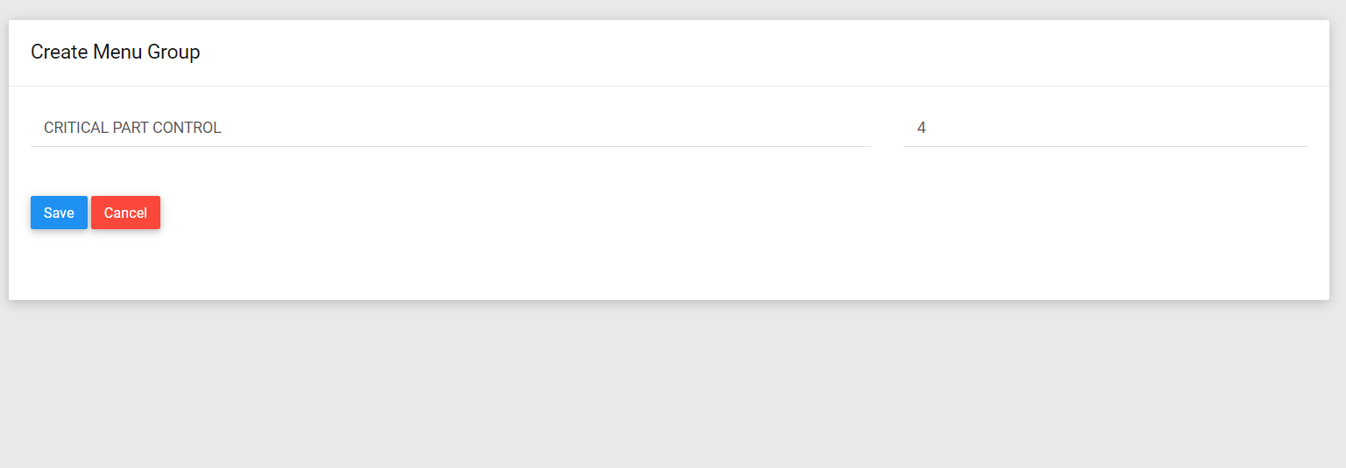

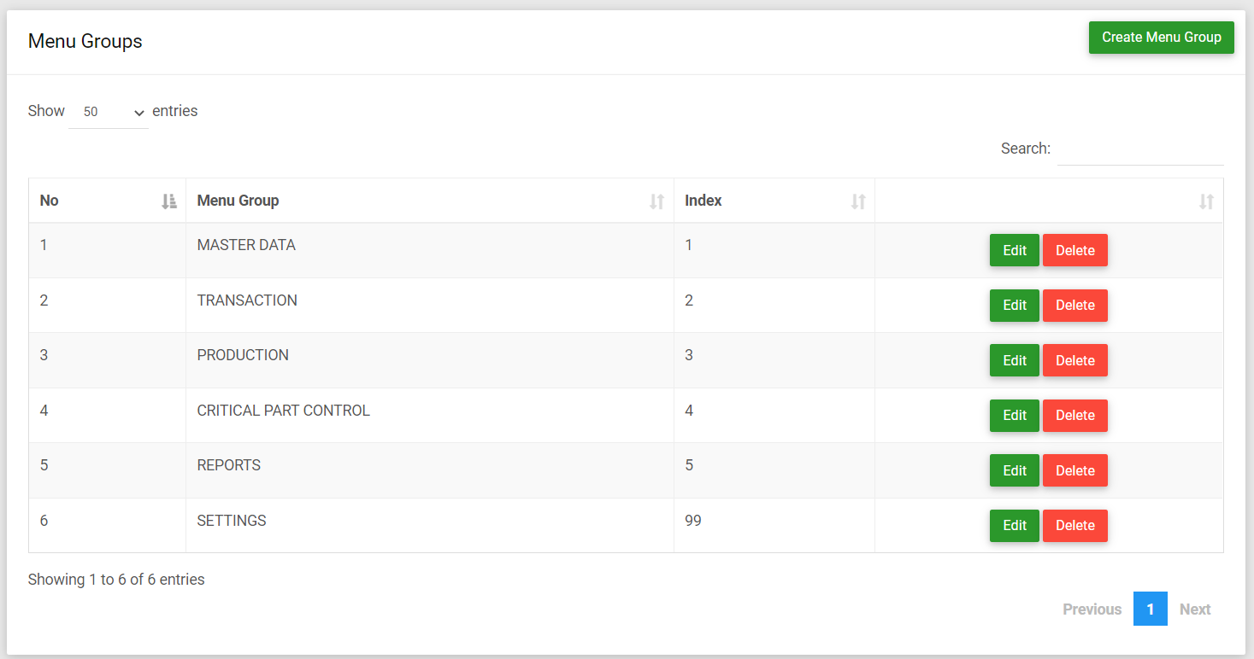

* Add New Application Menu



 
 